2011-2012 Systems Maintenance

This is technical document written for a programmer to enable them to maintain/ update your program/ database.

Only final versions need to be included in this document.

AQA summary

Candidate-written code/scripts listing that is self-documenting and/or well annotated, easy to follow (very easy to comprehend).

Explanation of the modular structure of all the code.

Reference to the design section.

Reference to testing.

Explanation of difficult to understand parts of code.

List or description of system settings/

Expected contents for this section of the report are:

system overview

a sample of the detailed algorithms as implemented by the candidate

procedure and variable lists with descriptions for programs, and a list of package items developed with

descriptions (if a package is used).

All cross-referenced to listings of candidate-written program code and representative samples of

annotated ‘design views’ showing details of forms, reports, queries; buttons, cross-tabulations etc that have

been tailored by the candidate (if a package is used).

This is technical document written for a programmer to enable them to maintain/ update your database/ program.

The mark given for this section is for the quality of the write-up, not the complexity of the program, so a simplistic project can access high marks.

Only final versions need to be included in this document.

  - Systems overview

Text Storage

File | Storage
Nodes.txt | Storage of all the values of the Node objects in a given problem. Saved in the format of spaces between variables and lines between new objects.
Edges.txt | Storage of all the values of the Edge objects in a given problem. Saved in the format of spaces between variables and lines between new objects.
Connections.txt | Storage of all the values of the Edge objects in a given problem. Saved in the format of spaces between variables and lines between new objects.

Java Classes
Package | Name | Purpose
GUI | CustomActionListener | Contains all the listeners used in this project (ActionListener, MouseListener,MouseMotionListener, FocusListener, KeyListener). Allows the user to interact with the GUI.
GUI | ProblemGraphGraphicsComponent | The graphics component which gets user input and allows them to draw their problem graphs into the program.
GUI | SolutionGraphGraphicsComponent | The graphics component that draws out the solution to the problem the person has entered
GUI | ProblemGraphPanel | Hosts the problemGraphGraphicsComponent as well as supplying buttons to the panel.
GUI | SolutionGraphPanel | Hosts the SolutionGraphGraphicsComponent.
GUI | ConnectionTable | Hosts the list of connections and their weights after they have been created.
GUI | ProblemTable | Hosts the problem in a table format once calculated. Can be used to input problem by user.
GUI | Main | Creates the base GUI as well as action listener, used as a controller.
Objects | Node | Contains the co-ordinates and label of a node in either the problem or the solution. Used for connections.
Objects | Edge | Contains the weight and ID of a vertices connecting two nodes, Used for connections.
Objects | Connection | Contains 2 node objects as a node[], an edge object as well as an ID to identify it. Used as the bases of drawing and solving problems.
Objects | Graph | Contains a dynamic list of connection objects, used to represent problems and solutions, also contains an ID.
 | Primms | The algorithm for preforming primms and hosting private methods for it.
 | Kruskals | The algorithm for preforming Kruskals and hosting private methods for it.
 | PrintAndSave | Used to print information through the terminal window and for saving and opening problems.

- Write a list of all the components of your system (java classes, database tables, files etc

Software | Component type | Component name | Purpose of component
MySQL | Table | tblCustomer | To store personal details of customers
MySQL | Table | tblStock | To store data about stock
MySQL | Table | tblOrder | To record date/ time of an order made by a customer
MySQL | Table | tblOrderDetails | To record the stock ordered
Java | Class | Controller | Contains action listener code for all GUI classes
 | Class | CustomerGUI | GUI to edit a customer

2.2 Table designs and relations

- Include screen shots of the final design of each table (from SQL or Access)
- include a screenshot of your relationship table

2.3 MySql SQL queries or reports

- Include examples of SQL queries that you have used to edit / search your database.
- Include screen shots of the design of any queries (QBA or SQL screens) and explain any calculations or aggregate fields
- Include screen shots of the design of any reports

2.4 User Interface – Java GUIs

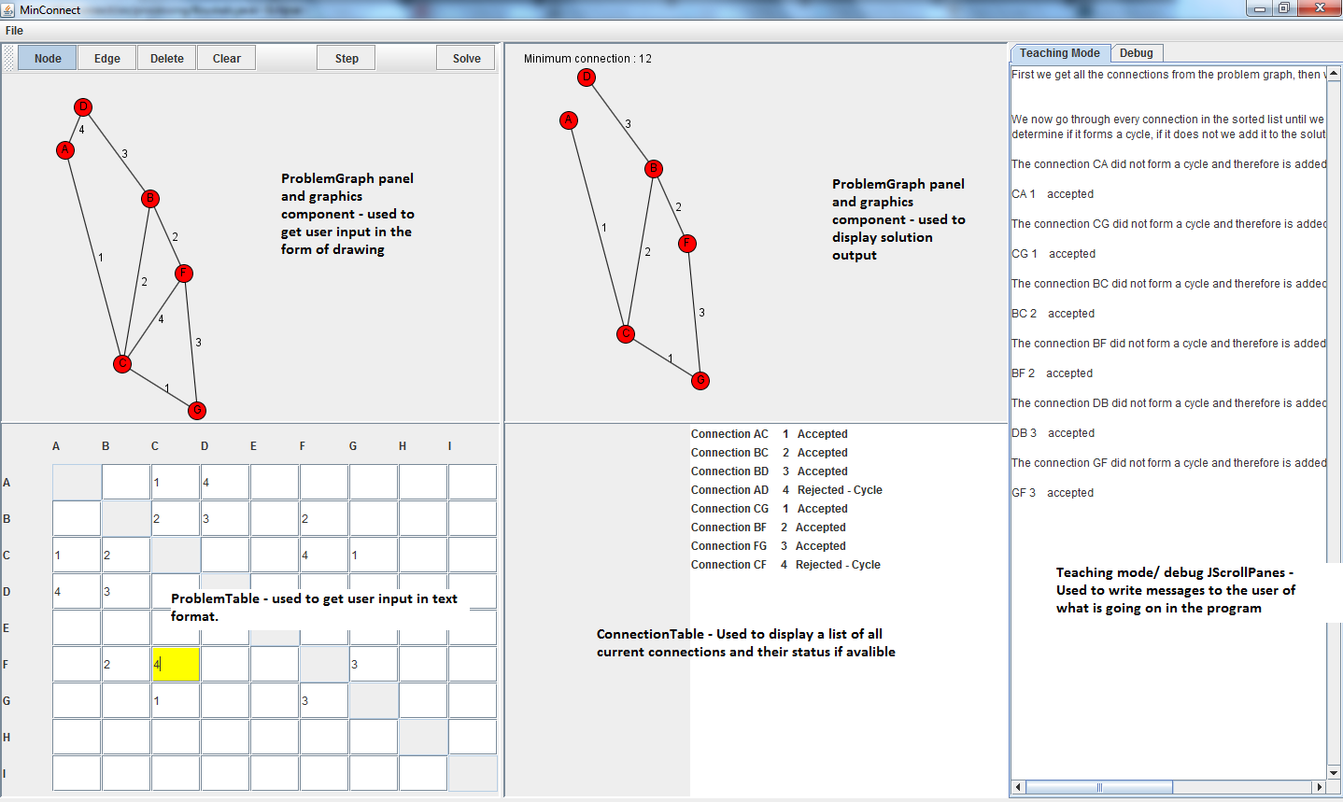

- Paste in a screenshot of each of your Java GUI JFrames and label the purpose of each.

2.5 Programming

For high marks on technical solution (15 marks), the moderator is looking for well-structured, non-repetitive code, making good use of parameters.

- Include annotated listings for all the code you have produced (as an appendix to this section)

Annotation of the program code is essential, but don’t write on every line of code, and don’t annotate repetitive coding more than once.

- Complete a routine table for all the methods in each class including methods that connect to the database (you could paste in the BlueJ interface?) Explain any parameters.

Class (where variable is used)
Name of routine | Kind | Scope | Return type (if function) | Parameter type list | Description
 | (Procedure or function) | eg global / public local / private | (e.g. int, String, boolean array, ResultSet, Statement, JFrame, etc) | (e.g. int, String, boolean array, ResultSet, Statement, JFrame, etc) | Explain how the routine is used in your program

- Complete a variable table for all the variables in each method / class.
Arrange this logically e.g. you could paste in the BlueJ interface showing how the classes are related and then list the methods by class and variables by class/ method. (You may want to use BlueJ to produce your API if you annotate code appropriately – see jaz)

Class / routine (where variable is used)
Name of variable | Kind | Scope | Type | Description
 | (Single or array) | eg global (prog / class) local (routine / for block) | (e.g. int, String, Boolean, ResultSet, Statement etc) | Explain how the variable is used in your program – explain carefully any SQL statements

- Include a sample of your algorithm design using one of the standard formats (or refer to relevant appendix) – choose one or two of your more complicated methods/ functions. Explain the parameters. (See S:\Computing\A2 Computing\legacy Specification\Mod6\Java Applet to draw JSP diagrams for a small package that draws JSP diagrams for you)

- Include any relevant OOP diagrams and OOP definitions (or refer to design section or appendix if not amended from design stage). For example screenshot from BlueJ showing inheritance and uses arrows.

2.6 Tricky programming problems

Whilst programming to draw the objects on screen, there was an issue where I could not just draw connection objects as first planned if it came from the graphical input. This is because in order to draw the connection the user would have to draw two nodes and an edge, but the user could not draw any edges as the nodes were invisible as they were never being drawn on their own, only connections. To resolve this I draw all the nodes first, and then just the edges from the connection.

Another problem I encountered whilst programming was getting the data from the table input in an efficient manner as I did it using 81 separate jTextFields . The solution in the end was to treat it as an array with reflection as 2 of the boxes mirrored each other and the user could write in whichever one he desired. As there were 81 jTextFields, the equation used to get which connection was (9r*c) or (9c*r), this was looped through two for loops and enabled me to recognise which box contained the weight for which connection.

A further problem I also encountered was that I could not find a suitable solution no matter how hard I tried to use just one graphics component for both the problem and solution graph, so in the end I had two graphics components, each drawing from a different set of connections, but with the solution graph drawing all the nodes regardless.

- Write about a programming problem that was tricky to solve or understand, and explain how it works and how you solved it! (This will show the moderator something about the level at which you are programming – preferably including something of adequate or complex complexity.)

2.7 Reference to other sections

- Refer to design section (or appendix) where appropriate – for example for algorithm designs, OOP definitions (possibly referenced in section 2.5 already).

- Refer to testing section (or appendix) where appropriate – for example for particularly difficult to understand programming.

2.8 Settings and configurations

- List or describe relevant system settings / configurations. For example use of debug mode (printing to terminal window), passwords / levels for program / database usage, setup status of program / database after installation / recovery.
All users will have access to the debug and teaching mode facilities of the program in which they can see what is being calculated in the background. There will be no user names or passwords as the file is run locally and as such there is no database connections as per the request of the client. There is currently no customisation but there are plans in the future to allow things such as the changing of font size, colours and the like.
2.9 Maintenance log

- Dated list of program modifications (should not be many as this should be for additions after this document is finished but before final hand in) – eg details of any modifications resulting from appraisal and user feedback.

21/04/2012
Changed the table input to 2D JTextArea array for ease of maintainability and readability.

22/04/2012
Generating table from graph working, lists showing whether accepted or rejected and all output text properly formatted.

23/04/2012
Limited user input of Strings to only single letters after testing to eliminate multiple bugs.

